Parts of speech in sign languages
Sign languages VS Spoken languages
- articulated and transmitted in a different modality from spoken languages
  - Would languages in a different modality display different kinds of word classes? For example, would the spatial nature of sign languages give rise to a word class that denotes spatial relations?
  - Would iconicity play a role in differentiating between word classes?
  - Do languages in a different modality have different set of properties to distinguish between word classes?
  - Do we need to develop a totally different set of tools to categorize signs?
- as a group are much younger than spoken languages => characterized by dearth of inflectional morphology (as creoles languages)
Signs VS Spoken words
- more simultaneously organized
- tend to be monosyllabic
- much better at iconically depicting the concepts they denote

Categorization and classification of signs according to their syntactic and morphological behaviour
- content words VS function words.
- content signs classes(nouns, verbs, adjectives)
  - generally open classes
  - tend to have specific meaning, usually extra-linguistic
  - tend to be fairly long
  - text frequency is rather low
- function signs classes (numerals, question words, negative words, pronouns, auxiliary verbs)
  - usually small and closed classes
  - usually defined by their function (no concrete meaning)
  - tend to be rather short(?)
  - text frequency is higher(?)
- Word classifications suggested for sign languages:
- according to the spatial characteristics of signs:
  - signs that cannot move in space at all (e.g. ‘understand’, ‘woman’ and ‘I’)
  - signs that are produced in neutral space and can be articulated in various locations in space
  - directional signs, that is signs that move between locations in space associated with referents.
- according to semantics, syntax, morphology

Nouns VS Verbs

Sign:
- movement component
- the handshape
- orientation
- location
- !MOUTHING!

Criteria:
  - the quality of the movement component Fig 5.2:
    - in nouns it is reduplicated, restricted, and constrained; the movement of the related verbs is not.
    - the verbs typically have a longer movement
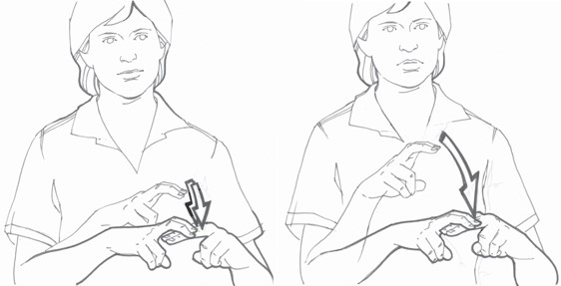
- ASL: chair sit
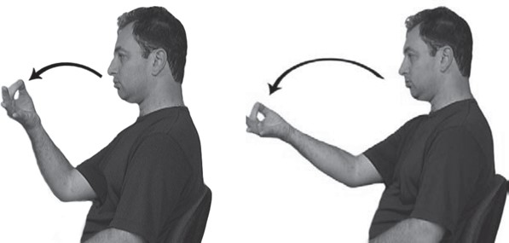
- Israeli SL: question ask
Fig. 5.2: a. ASL noun-verb pair: chair-sit; b. Israeli SL noun-verb pair: question-ask. Figure a reprinted wth permissions from Padden (1988). Figure b Copyright © 2011 by Sign Language Lab, University of Haifa. Reprinted with permission.
- Inflectional affixes (selective with respect to the lexical base they attach to) inflections are diagnostic of a syntactic position more than a specific word class, but depends on lang.
    - Verbs: (a) Encoding arguments: verb agreement; reciprocal; multiple; exhaustive. (b) Aspect: habitual; durational; continuative; iterative; protractive; delayed completive; gradual.
    - Nouns: plurality.
    - Predicative adjectives: pre-dispositional; susceptative; continuative; intensive; approximative; iterative; protractive
Problems:
    - No single morphological operation applies across the board to all members of a particular concept class
    - Characterizes only agreement verbs
    - Operations are limited in their productivity, and it is difficult to determine whether they are derivational or inflectional
    - Since all these inflections involve modulation of the movement component, sometimes their application is blocked for phonological reasons.
    - Can help in establishing word classes for particular languages, with corroborative evidence from semantic, syntactic, and distributional facts.
- Word-class-determining affixes
- very few refer to the part of speech of the resulting words
- a class of prefixes in Israeli SL that derive verbs. This class includes signs made by pointing either to a sense organ the eye, nose, or ear or to the mouth or head.(prefixes behave as verb-forming morphemes.) e.g. fig 5.3

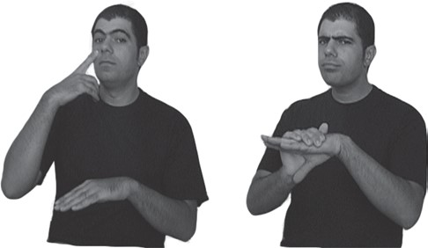
eye catch
Fig. 5.3: Israeli SL sign with a verb-forming prefix: eye+catch ‘to catch red handed’. Copyright © 2011 by Sign Language Lab, University of Haifa. Reprinted with permission.
- another set of complex words in ABSL refers to objects, and contains a component indicating the relative length and width of an object by pointing to various parts of the hand and arm, functionally similar to size and shape specifiers in other sign languages (Sandler et al. 2010; Meir et al. 2010). The complex signs refer to objects, and are therefore considered as nouns, though the base word may be a verb as well: cut+long-thin-object is a knife, drink-tea+round-object is a kettle (Figure 5.4b).
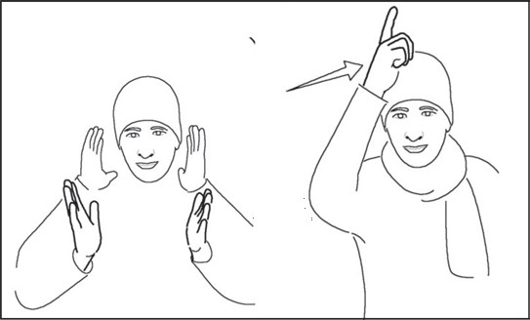
- pray there
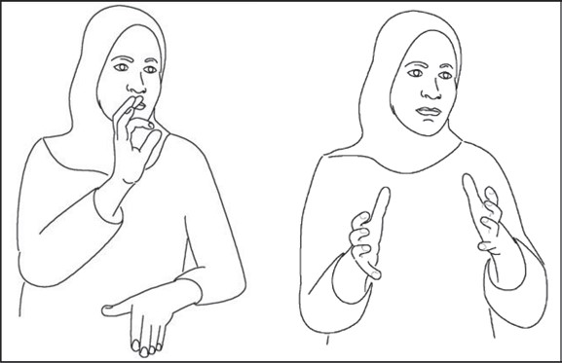
- drink tea+round-object
Fig. 5.4: Two ABSL complex words with suffixes determining word class: a. Locations: pray+there ‘Jerusalem’; b. Objects: drink-tea+round-object ‘kettle’.
- Co-occurance with function words
    - ÖGS nouns can be modified by quantifiers, indices, adjectives, and size and shape classifiers (SASS) are more often adjacent to nouns than to verbs.
    - modal verbs tend to occur much more often next to verbs than next to nouns
    - the former co-occurs with nouns (signs denoting entities, as in sentence (2), below), the latter with verbs (signs denoting actions, as in sentence 3)

- ix₁computer neg-exist-1/*zero-1/2/*not [Israeli SL]
‘I don’t have a computer.’
- ix₃ sleep zero1/2/*neg-exist-1/2
‘He didn’t sleep at all/He hasn’t slept yet.’
- chair ix_{A} comfortable not/*zero-1/2/*neg-exist-1/2
‘The chair is/was not comfortable.’

- Co-occurance with non-nominal features
    - Israeli SL has facial expressions denoting manner such as ‘quickly’, ‘meticulously’, ‘with effort’, ‘effortlessly’, which modify actions, and can be used as diagnostics for verbs.
    - Mouthing turns out to be selective as well. In the studies of noun-verb pairs in ÖGS and Auslan, it was noticed that mouthing is much more likely to occur with nouns rather than with verbs
Russian Sign Language
Experiment:
43 noun-verb pairs referring to concrete objects and actions involving these objects
1. short videotaped scenes (For example, there was a short scene involving matches which was expected to elicit the nominal sign match or matches. Another scene which showed a boy striking a match was we expected to yield the verbal sign strike-match or a sentence with the meaning ‘a boy strikes a match’.)
2. the videotaped signs, which supposedly reflect nominal or verbal meanings (to find out whether the phonological differences which had been identified following stage 1 were meaningful for the observer, that is, whether they would help the RSL signers to distinguish nouns from verbs)

I. Repeated vs. single movement
Figure 4. door (if repeated) or door-close (if single)

II. Movement vs. lack of movement
appears to be unique to RSL

III. Amplitude differences
A verb contains a wider movement amplitude than the corresponding noun.
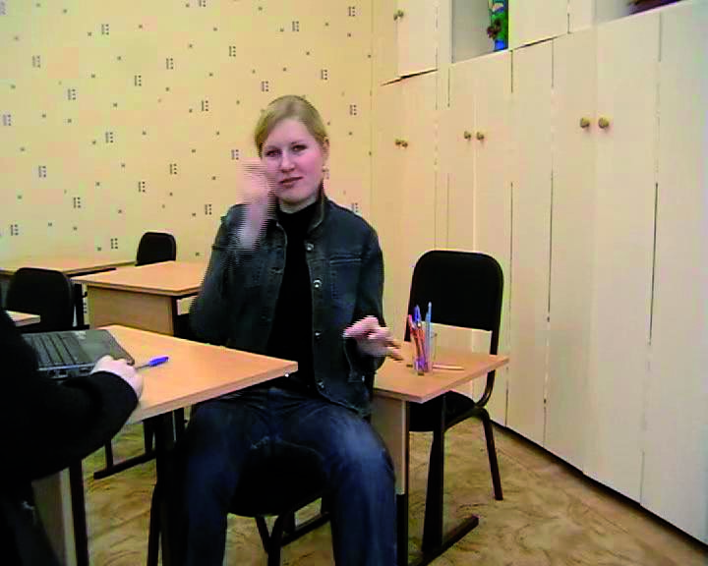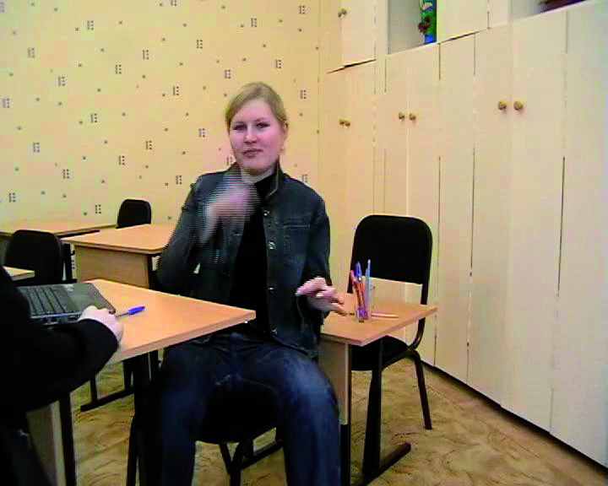
Figure 5. hammer_{N}
Figure 6. hammer_{V}

IIIa. Contact vs. lack of contact
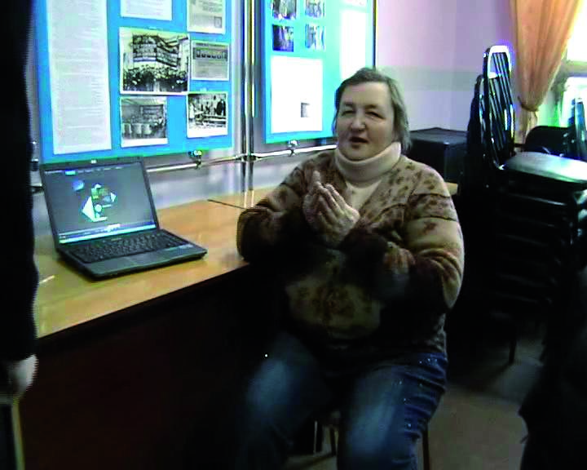
Figure 7. book
Figure 8. open-book

IV. Number of joints involved
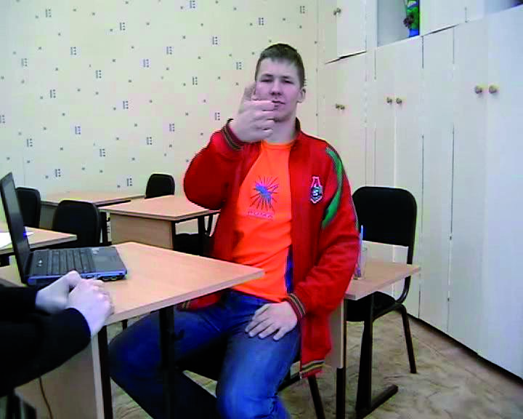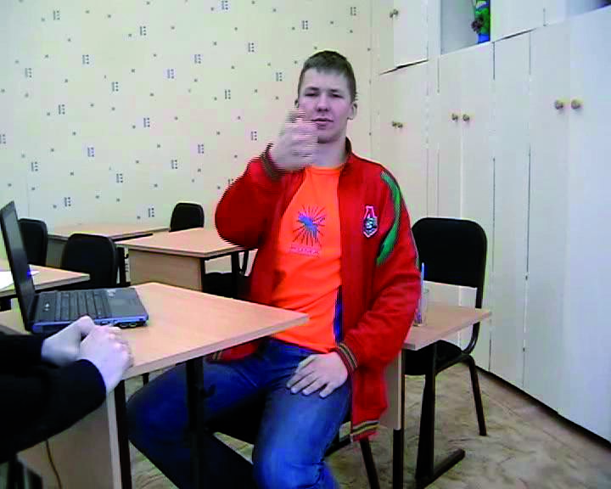
Figure 9. lighter (single movement): only the thumb (interphalangeal joint) is used
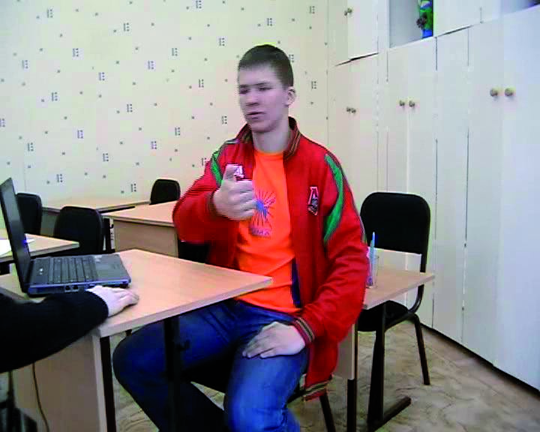
Figure 10. light-lighter (repeated movement): at least the thumb and the elbow joint are used

V. Differences in handshape
knife — cut-with-knife, saw_{N} — saw_{V}, iron_{N} — iron_{V}.
The RSL nominal sign knife, for instance, is made with the k-handshape (from the Russian Manual Alphabet) while the corresponding verb cut-withknife is made with the b-handshape (see Figure 11 for illustrations).
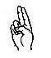

Figure 11. Letters K and B of the Russian Manual Alphabet

VI. Orientation differences
(different palm orientations) wiper — wipe (see Figure 13), plug — insertplug, umbrella — open-umbrella.

VII. Location differences
.hat — put-on-hat (see Figures 14 and 15)

VIII. Mouthing
We cannot say whether this observation also holds for RSL because of the small amount of relevant usages.
Overall, only 4 noun-verb pairs (9%) could be distinguished by one difference only, 3 pairs (7%) were not distinguished at all in our database, and 36 pairs (84%) could be distinguished by at least 2 differences.
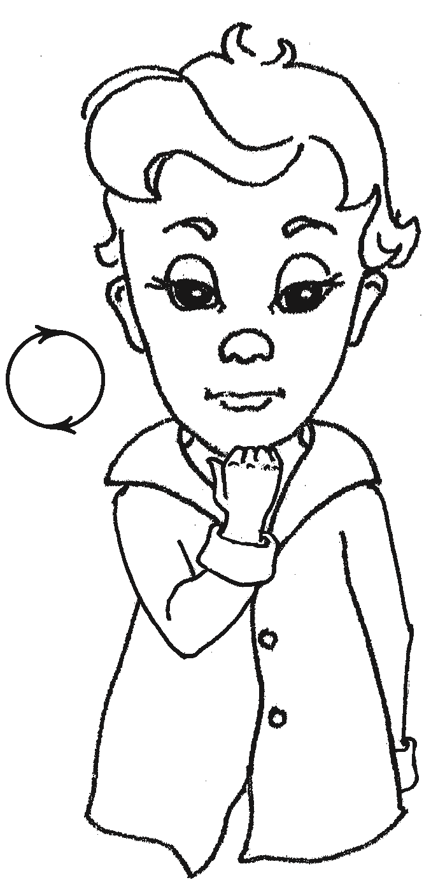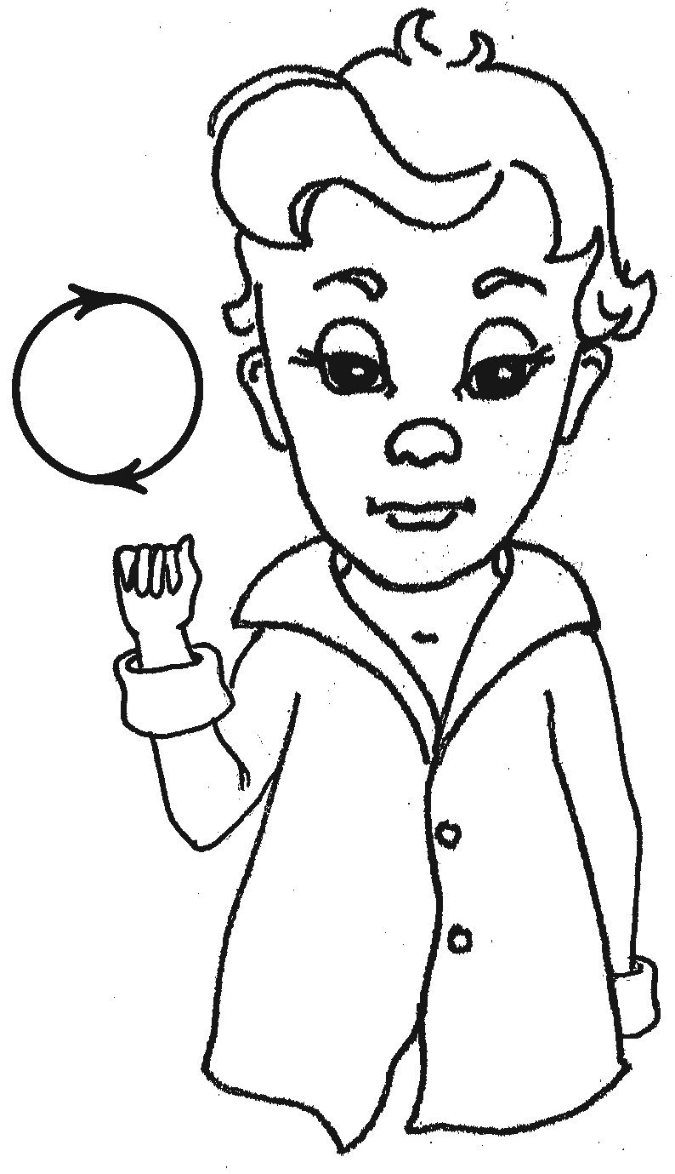
a. b.
Figure 13. (a) Nominal sign wiper; (b) Verbal sign wipe

Iconicity vs. economy
Higher iconicity of verbs and the higher economy of nouns (hat — put-on-hat depicted in Figures 13 and 14)
Figure 14. hat
Figure 15. put-on-hat
- it is articulated on the head (with contact);
- the movement is more precise in that the hands follow the form of the head. Articulation of the noun sign hat, on the other hand, is more “economic” because
- it is articulated in the neutral signing space (in front of the chest) (difference VII);
- the movement is short and unmarked: the trajectory is straight (difference
III);
- it uses only the wrist joint (difference IV).
This analysis also provides an explanation for the fact that mouthing is much more common with nouns than with verbs. The more economic articulation of nouns makes them less perceptually salient. Mouthing can therefore be considered a supportive system which obviously facilitates the interpretation of a sign.
Literature
1. Meir, Irit (2012). ‘Word classes and word formation’. In: R. Pfau, M. Steinbach and B. Woll (Eds.). Handbook on Sign Language Linguistics. Berlin: Mouton De Gruyter, 365-387.
2. Vadim Kimmelman (2009) Parts of speech in RSL: the role of iconicity and economy

